**How to add users on tin0, tin1, tin2, and cobalt with sudo privileges**

**Step 1: Install PuTTY**

The most common method to connect to a server with an IP address is through SSH on Windows PC by using a software called "PuTTY".

Here is the URL to download PuTTY from: <https://www.chiark.greenend.org.uk/~sgtatham/putty/latest.html> . It is a quick installation with easy steps.

**Step 2: Connect to Global Protect:**

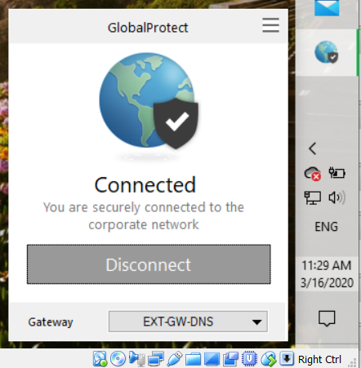

**Step 3: Log in through PuTTY**

To log in to tin0, tin1, tin2 and cobalt in PuTTY insert IP address in Host Name section, then when in shell (inside PuTTY), start typing command as shown on print screens below.

* **Tin0, IP 192.168.200.20**

Make sure the "port" is 22 and the "Connection Type" is selected as SSH.

Click on "Open" and a dialog will pop up to ask if you want to authenticate this connection. Click "Yes".

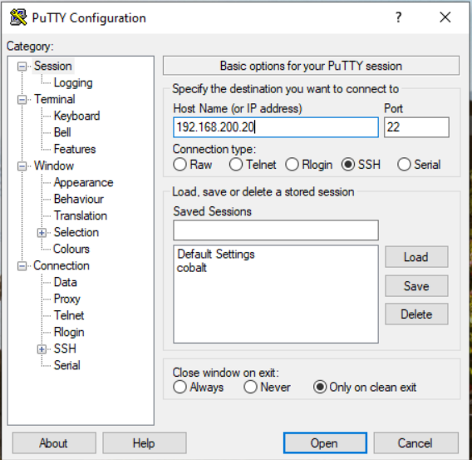

A new window will ask for username and password credentials to finish the login like shown on the picture below.

To create your own account on tin0, go to root first and then create an account with commands: **adduser username** and **passwd username**

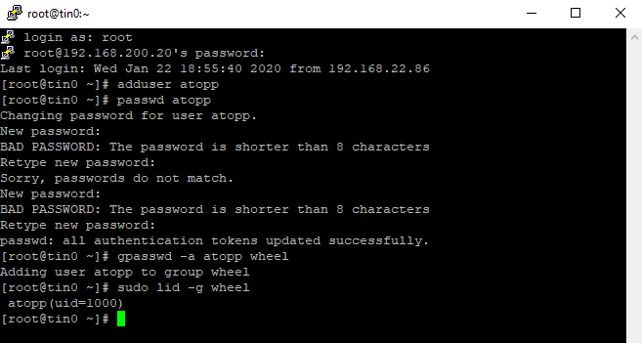

To connect, create a new user and password for tin1, tin2 and cobalt, proceed with the same commands by changing IP addresses only:

* **Tin1, IP 192.168.200.21**

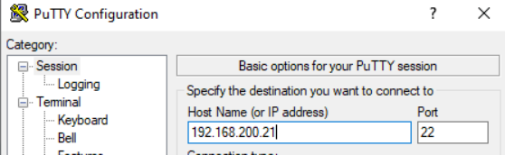

* **Tin2, IP 192.168.200.22**

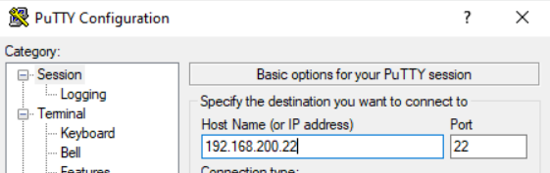

1. **Cobalt -> IP 192.168.200.19**

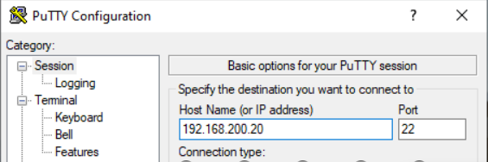

References

DigitalOcean. (2019, September 18). How to Add and Delete Users on a CentOS 7 Server. Retrieved from <https://www.digitalocean.com/community/tutorials/how-to-add-and-delete-users-on-a-centos-7-server>